‘I am an instrument of God’s love’
a mini retreat for Caregivers in a Covid World

Introduction
The Covid pandemic has uprooted our lives and turned our daily routines upside down. Anxiety about our loved ones as well as ourselves is ever present in the light of the spread of the pandemic.
And yet even before the lockdown and other restrictions our lives were sheltered and often isolated by meeting the needs of our loved one.
Our faith and those around us can bring us through this crisis. God gives us his message of love and hope in spite of, and possibly because of – the tribulations which we must endure. With every difficult moment comes an opportunity to reflect on how we can live out this message of love and hope in our role as caregivers. We can learn the virtue of compassion both for our loved one and equally for ourselves - yes – self-compassion is a virtue which we can develop as well. And this applies whether we are family caregivers or whether we provide our care in a residential or nursing setting.
In this resource we reflect for a cycle of a week on a bible reading or reflection, we practise a short period of reflection and finish with a suitable prayer. You will need no more than 15-20 minutes but to try to ensure that for this – and other relaxation - you give yourself some ‘me time’ – you will feel better for it ass well as helping to gain the strength which you need to sustain you for the days ahead. Make sure that you are seated or perhaps lying in a comfortable position - you may wish to relax in advance by listening to some of your favourite music.

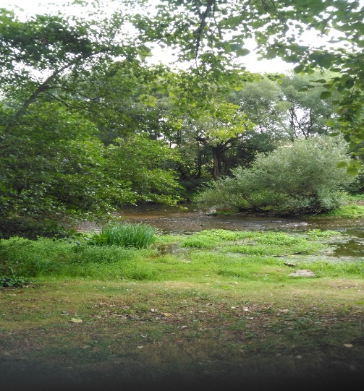

Sunday: ‘Come unto me all who labour’...
‘Come unto me all you who labour and are heavy laden, and I will give you rest. Take my yoke upon you, and learn of me for I am meek and lowly in hert, and you shall find rest unto your souls. For my yoke is easy and my burden is light.’ (Matthew 11 28-30)
Being a caregiver feels often like never being able to relax. We may have prepared a cup of tea for our loved one and have sat down, only to be told that there is not enough milk or sugar ! And I was never supposed to be a caregiver until my wife had a serious stroke. And yet there is a simple message in this comforting passage from Matthew – God loves both me and my loved one – and I am the instrument through which God expresses His love for Mum in spite of the challenges we both face. And just as God loves both of us help me to spend some precious moments each day in prayer and reflection in thanksgiving for that love.
Reflect for a few minutes on the acts of love you have given or experienced in the course of today. Can you cherish these acts as you go forward to another day ?
Thank you Lord for helping me to see that my caring is not just a daily drudge - it is an act of love made in your name. Help me to be an instrument of your love, providing tenderness and understanding even – and especially – when the going gets tough. Let me show that love even when I cannot touch the other person. Help me to renew my sense of commitment.

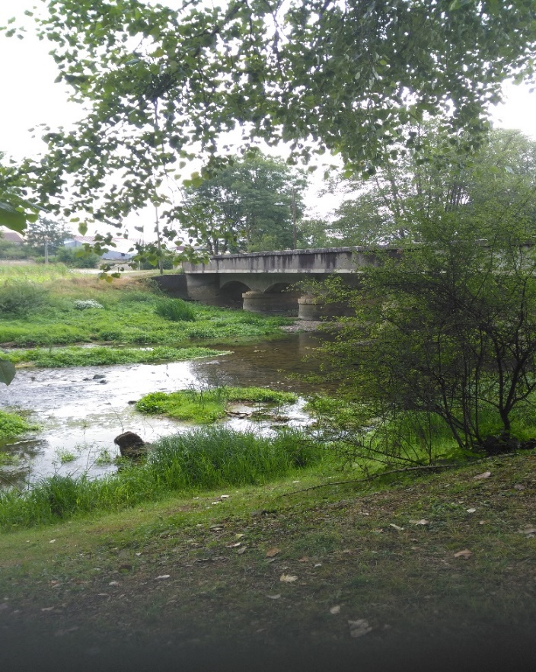

aqMonday – Finding our compassionate selves
And therefore, as God’s chosen people, holy and dearly loved, clothe yourself with compassion, kindness, humility, gentleness and patience. (Colossians, 3.12)
Our compassion is a feeling of deep sympathy and empathy for someone who is suffering or who is in pain – the greatest example is Jesus Christ himself. His death on the Cross was the truest and most authentic act of compassion that anyone could make.
And so we in our daily caregiving, even in the most mundane tasks, follow the example of Christ himself. In our moments of impatience and frustration, let us let this feeling of compassion and love enter our hearts and minds.
And don’t forget that the other person on whom to practise compassion is yourself. You might want to learn to develop the practice of self-compassion. You will find more information on self compassion on this page with practical exercises on Soundcloud
Prayer: Lord, again and again in the Scriptures you teach us the value of compassion with our brothers and sisters in humanity. Just as you have taught us about the divine level of compassion, help us to put it into practice in our daily lives and more especially those all for those for whom we provide our care. Then we will be truly authentic witnesses of the love which you hold for all humanity

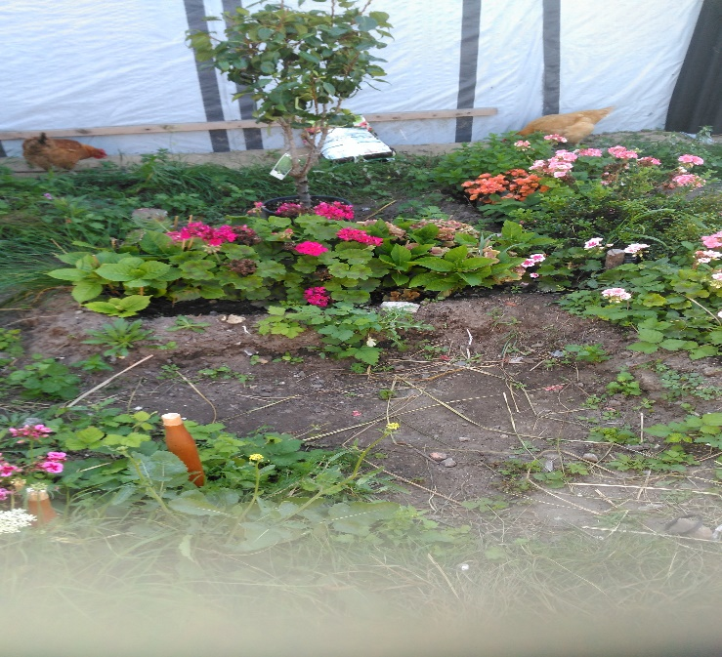

4Tuesday – ‘Yours are the hands through which he blesses all the world’`
‘‘Christ has no body but yours; no hands, no feet on earth but yours
Yours are the eyes with which he looks Compassion on this world. Yours are the feet with which he walks to do good, Yours are the hands through which he blesses all the world. Yours are the hands, yours are the feet,
Yours are the eyes, you are his body. Christ has no body now but yours, No hands, no feet on earth but yours.
Yours are the eyes with which he looks compassion on this world. Christ has no body now on earth but yours’.
St Teresa of Avila
I love these words by St Teresa of Avila which helps us to understand that our hands in the task of caring are those of God himself. Even at times when we find our caregiving frustrating and tiring, we can remind ourselves that we are doing nothing less than God’s precious work – and what a comfort this is in our daily tasks...
‘Lord, as I reflect for a few minutes in the peace of the evening I thank you for the insights you have given me to understand that I am an instrument of your love and that all my actions each day have a divine purpose. At times when I feel I cannot cope, remind me that I am part of your divine plan and that you have given me the ‘garment of compassion’ in reaching out to our Dad.’

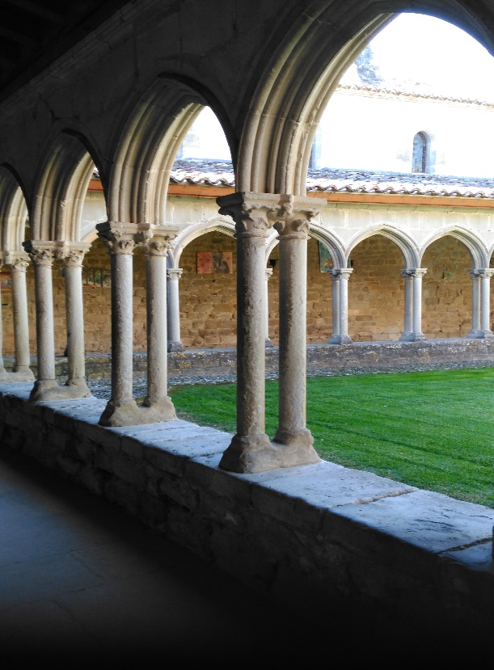

Wednesday – Thank you for the blessing I received from Mum
‘Fear not, for I am with you; be not dismayed, for I am your God, I will strengthen you, I will help you, I will uphold you with my righteous right hand.’ (Isaiah 41:10)
‘Tonight Mum was struggling as I helped her to get into bed. I nearly despaired and then I thought that maybe I could help her to be calm with her favourite hymns and prayers from the past. We listened to the ‘The Lord is my Shepherd’ and for the first time we said the Lord’s prayer together. And as she settled to sleep she said ‘I enjoyed being with you tonight - thank you and bless you’.

Lord, thank you for helping to see Mum in a different light today. I must learn to see Mum not as someone who is a burden and needs ‘care’, but rather as an instrument of your love and your peace. Yes Lord, you choose the ‘least among us’ to witness to you and to all of us in difficult times. And when I see Mum in the morning and I shall remember that just as you bless our family, so blesses us as well in your name.

Thursday ‘When you find no beauty, put beauty St John of the Cross
‘You are altogether beautiful, my darling; there is no flaw in you’... (Sol, 4,7)
Care giving is not always a beautiful task. Each day we may have to contend with a pile of soiled linen, or pads which we need to dispose of. And its important to keep a sense of proportion and hold on to the fact that God’s creation is by nature an act of creating beauty. It was in this spirit that Mother Teresa referred to the work of her Order as ‘something beautiful for God’.
Think of something beautiful that you have experienced in the last few months. It could be a walk in the park or in your garden, when you have seen flowers blossoming or the trees in their full growth. It could be a special picture that you have on the wall – perhaps memories of a special occasion such as a baptism or a wedding. when everyone put on their best clothes. Or a picture of a favourite grandchild. And as you carry out your caregiving remind yourself of the beauty of the images you have chosen which represent the best in Go’d work of creation’ And remember that the person you are caring for might want to be reminded about their beauty as well.
Prayer: Lord, in the midst of my daily chores and th Covid pandemic I sometimes find it hard to see what is beautiful in our lives. Be with me Lord as I search to find the beauty which is all around me - the pictures on the walls which bring back such happy memories, the flowers in our indoor garden, the trees n the park nearby, and yes, the beauty I can still see in the face of Mum in spite of her advancing years – the beauty with which you endow all of your creation’

Friday: ‘The final word is love’ (Dorothy Day)
‘A new commandment I give to you: That you should love one another as I have loved you (John 15:12)

I love these words of Dorothy Day who founded the Catholic Worker Movement. As we go about our daily tasks we can so easily see ourselves as carrying out our obligations, sometimes with satisfaction and sometimes if we are honest with a degree of resentment, particularly if we are feeling tired or under the weather.
It is at these times that we need to recall that simple word ‘love’ as the rationale for all that we do. All too often our love might have withered, perhaps neglected as we face the challenges of daily life in our advancing years. And yet love is a bond which has bound us from our time when we married. We need help and support in rediscovering this dimension of our life. And as we complete our tasks for the day we remind ourselves that the love which shone so strongly in our younger years still has the final word.
Prayer: Lord, again and again you remind us that even in our darkest times the one constant is love. Through your divine love you show us how we are to love through your exaple even when it seems impossible. Help me Lord to remember this as I go about my daily tasks of caregiving – fill me with the peace and tranquillity which comes from showing – and being showed - true love today and in the time to come.

Saturday: ‘I must resist harsh words’

‘A gentle answer turns away wrath, but a harsh word stirs up anger. The tongue of the wise adorns knowledge, but the mouth of the fool gushes folly. The eyes of the LORD are everywhere, keeping watch on the wicked and the good. The soothing tongue is a tree of life...' Proverbs 15 - 1-4
How true these words ring in an age of social media and immediate judgements. Each day we are faced with different problems – ‘How can i protect myself and my loved one in the face of Covid’ ? How can I get the shopping when all the delivery slots have been taken ? How do I manage if the carers are off sick ? What happens if my loved one needs a doctor ? And can I get help for Mum if the hospitals are overrun through the Covid pandemic ? The list seems endless. I must learn to understand and work through problems without rushing to judgement and venting my anxiety and anger. I need to ralise to realise that it is no use worrying about problems I can do nothing to solve – instead I must be confident that God will help me to find a way through.There is usually a solution to every little problem but we might need to find a few moments of peace and tranquillity to see the solution more clearly.
Prayer: There are so many uncertainties and obstacles in our current troubled world. Our Father in Heaven, please help me to be sensitive to the rough places that need smoothing Help me to be somone who can sooth, smooth, and heal by my actions and my words. Then I will truly be an instrument of your love and compassion. (Marilyn Driscoll)

